Problem 1:
DEF-USE Table:

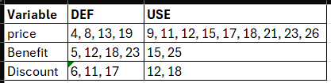

DU-PATH Table:

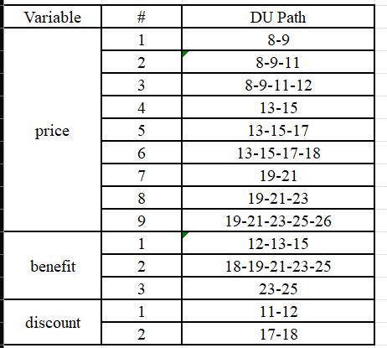

Problem 2:
DEF-USE Table:

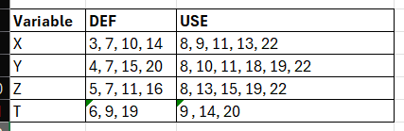

DU-PATH Table:

